

Spring Thaw

Water
Of
Life

Order Of Service

Opening Hymn: TLH 141

Reading: Lent II

The History of the Passion of our Lord

Sermon Hymn: TLH 151

Sermon Text: Luke 12:13-21

The Rich Fool

Confession of Sins: O almighty God, merciful Father, I, a poor miserable sinner, confess unto Thee all my sins and iniquities, with which I have ever offended Thee and justly deserved Thy temporal and eternal punishment. But I am heartily sorry for them and sincerely repent of them, and I pray Thee of Thy boundless mercy and for the sake of the holy, innocent, bitter sufferings and death of Thy beloved Son, Jesus Christ, to be gracious and merciful to me, a poor, sinful being.

Holy Communion

The Lord's Prayer

The Blessing

Closing Hymn: TLH 147

* * * * * * * * * * * * *

Koinonia Hour
18 And he said, This will I do: I will pull down my barns, and build greater; and there will I bestow all my fruits and my goods.
19 And I will say to my soul, Soul, thou hast much goods laid up for many years; take thine ease, eat, drink, and be merry.
20 But God said unto him, Thou fool, this night thy soul shall be required of thee: then whose shall those things be, which thou hast provided?
21 So is he that layeth up treasure for himself, and is not rich toward God.

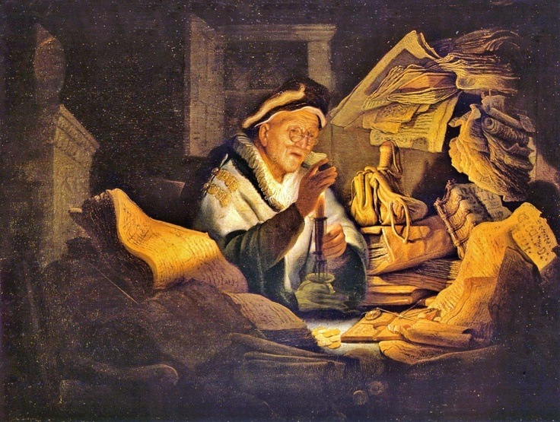

6 March 2022

W A T E R O F L I F E

Independent Christian Church—Conservative Lutheran Doctrine

Worship Service: 9:30 a.m. Bible Study: 10:45 a.m.

Larry Cooper, Pastor E-Mail address:
111 N. Ridge Road lcooper@wateroflife.cc
Coon Valley, WI 54623 Web Site:
www.wateroflife.cc

* * * * * * * * * * * * * * * * * * * * * * * * * * *

Sermon Text: Luke 12:13-21

The Rich Fool

* * * * * * * * * * * * * * * * * * * * * * * * * * *

13 And one of the company said unto him, Master, speak to my brother, that he divide the inheritance with me.
14 And he said unto him, Man, who made me a judge or a divider over you?
15 And he said unto them, Take heed, and beware of covetousness: for a man's life consisteth not in the abundance of the things which he possesseth.
16 And he spake a parable unto them, saying, The ground of a certain rich man brought forth plentifully:
17 And he thought within himself, saying, What shall I do, because I have no room where to bestow my fruits?

